**Rodent road ecology in south Texas and the potential bottom-up effects on rodent predators**

Author: Adam Sanjar

**Abstract:**

In the field of road ecology, rodents are a taxonomic group which is understudied and could potentially be influential for the road ecology of other species. In the south Texas region rodents could be particularly influential due to the significant rodent predators in the region. This project will address aspects of the road ecology of rodents and their potential impacts on the interactions of rodent predators with roads and wildlife crossings on Laguna Atascosa NWR. Diel activity patterns will be generated for rodents in different road and undisturbed habitats to show any differences in rodent temporal activity in a series of stacked bar charts. To analyze the effects of landscape and structural features a PERMANOVA or ANOSIM will be run to generate results indicating the significance of any differences in sites. Direct comparisons between predator and rodent at sample sites will consist of linear regressions to discover potential correlations between rodent activity and predator abundance.

**Introduction:**

The native rodent species community is a vital components of south Texas ecosystems, they not only play important roles as herbivores, scavengers, and predators (Dickman 1999), but they are also the primary prey for many species in the region, including bobcats (*Lynx rufus*), coyotes (*Canis latrans*), and federally endangered ocelots (*Leopardus pardalis*) (Booth-Binczik, Bradley et al. 2013). Due to their importance and potential effects on other species, the effect of increased urbanization and human development on rodents needs to be assessed to most effectively manage and conserve native wildlife. The effect of roads and wildlife crossing structures in particular on rodents has been understudied or completely disregarded, but much of the literature which is available indicates notable effects on some rodent species linked to roads (Kozel and Fleharty 1979). In south Texas, this gap in knowledge leads to an incomplete understanding of not only how rodent populations are changing because of these roads and structures, but also whether rodents could function as drivers for how rodent predators interact with roads and crossings.

**Objectives:**

This project aims to make progress in addressing some of the most relevant questions regarding rodents around roads. First, the diel patterns of rodents around roads and crossings will be compared with diel patterns of rodents in reference habitat to assess impacts to rodent temporal activity. Second, rodent abundance and community structure will be assessed in relation to structure and landscape features to identify potential factors which affect rodents. And lastly, rodent activity will be compared with predator abundance to determine if there is the potential for a link between the variables.

**Methods:**

Rodent data will be gathered utilizing photobooths which have been used to effectively survey for rodents on prior surveys in other regions (McCleery, Zweig et al. 2014). Data for predator species will be taken from a long-running monitoring project of SH 100 and FM 106. The study area will be limited to the monitored sections of SH 100 and FM 106, which are both in Cameron county primarily on Laguna Atascosa NWR property.

Data from the photobooths will be manually sorted to the species level and then processed using R code which will output a .csv file with independent occurrences calculated based on a 30-minute interval of independence. Predator data from the monitoring project will be manually sorted to the species level as well, but independent occurrences will be based on both a 30-minute interval of independence and by observed behavior in the photos.

The compiled data will then be processed using the pandas, numpy, and matplotlib packages in Python. The number of independent interactions will be plotted in a stacked bar plot with each bar showing an hour of the day. This code has already been written and used to generate a sample figure with preliminary data (Fig. 1). Once a complete dataset is collected, stacked bar plots will be generated for each of the different site categories.

Landscape and structure factors will then be analyzed utilizing the vegan package in R. If the data set is large enough to have sufficient sample sizes for factors such as water presence, vegetation type, and road type then a PERMANOVA will be run to determine significance. If the dataset is limited then an ANOSIM will be run with the base factors of site type and habitat type.

A linear regression will then be run to compare rodent activity with predator abundance. This regression will be generated in python using the pandas, numpy, and matplotlib packages. A second regression of just significant rodent prey species (*Neotoma micropus* and *Sigmodon hispidus*) and predators will also be generated. This data will be presented as a series of scatterplots with trend lines upon completion.

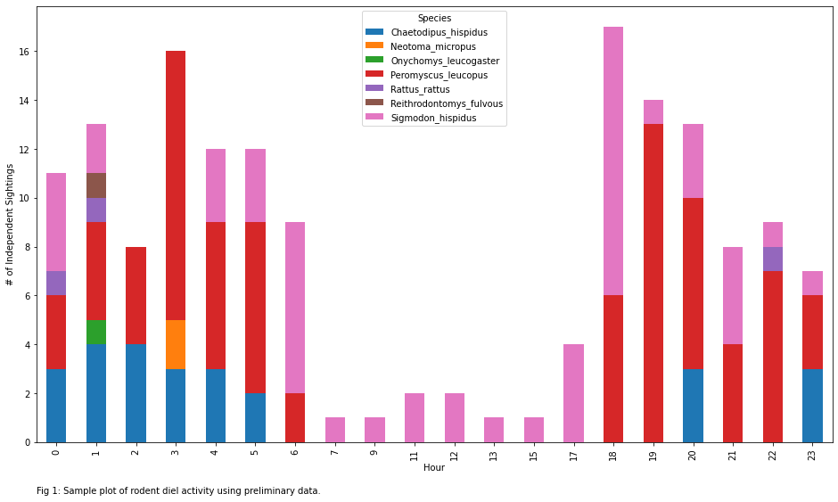

**Timeline:**



**Bibliography:**

Booth-Binczik, S. D., et al. (2013). "Food habits of ocelots and potential for competition with bobcats in southern Texas." The Southwestern Naturalist **58**(4): 403-410.

Dickman, C. R. (1999). "Rodent-ecosystem relationships: a review." Ecologically-based management of rodent pests. ACIAR Monograph **59**: 113-133.

Kozel, R. M. and E. D. Fleharty (1979). "Movements of Rodents across Roads." The Southwestern Naturalist **24**(2): 239.

McCleery, R. A., et al. (2014). "A novel method for camera-trapping small mammals." Wildlife Society Bulletin **38**(4): 887-891.